Femtosecond filamentation of optical vortex in a medium with anomalous group velocity dispersion
Evgeny Vasilyev, Svyatoslav Shlenov, and Valery Kandidov¹
¹Lomonosov Moscow State University, Faculty of Physics and International Laser Center, 119991 Moscow, Russia
Abstract. Within the framework of the slowly varying wave approximation method, the pictures of spatio-temporal dynamics of femtosecond pulse in a ring beam with phase singularity were obtained during propagation in CaF₂ crystal with anomalous group velocity dispersion. We show formation of tubular structure of the beam and explain reasons of its appearance. Fluence and linear plasma concentration dependencies on propagation distance are analyzed.
Filamentation of laser radiation is a phenomenon of formation of a long spatiotemporal structure with high power density [1]. Femtosecond filamentation has been widely studied for Gaussian and other beams with a smooth phase [2, 3]. Filamentation of circular beams with phase dislocations can be promising for such applications as tubular refractive index micromodifications, electrons accelerations, etc [4]. We have numerically investigated the filamentation of a femtosecond laser pulse in fused silica for the case of an annular beam with a phase singularity at a wavelength of 800 nm [5]. In this paper, we study propagation of a pulse in mid-IR in circular beam with phase dislocation in presence of anomalous group velocity dispersion typical for calcium fluorides.
A numerical simulation of the problem was performed based on the system of differential equations for the slowly varying complex envelope of laser field $A(r,t,z)$ and free-carrier concentration $N_{e}(r,t,z)$:
$$\left\{\begin{aligned}2ik_{0}\frac{∂A}{∂z}={\hat{T}}^{-1}\left[\left(\frac{1}{r}\frac{∂}{∂r}\left(r\frac{∂}{∂r}\right)-\frac{m^{2}}{r^{2}}\right)A\right]+\hat{D}\left[A\right]+\frac{2k_{0}^{2}}{n_{0}}\left(∆n_{k}-∆n_{pl}\right)A-ik_{0}\left(σN_{e}+α+δ\right)A, \\ \frac{∂N_{e}}{∂τ}=R_{E}\left(N_{0}-N_{e}\right)+N_{e}\left(ν_{i}-β\right),\end{aligned}(1)\right.$$
where $\hat{T}$ is operator of wave nonstationarity [1], describing self-steepening of wave front, $\hat{D}$ - dispersion operator, which is calculated in spectral domain according to Sellmeyer’s formula. The model takes into account beam diffraction and pulse dispersion, Kerr’s and plasma nonlinearities, Bremsstrahlung effect, nonlinear absorption and extinction, avalanche ionization and electron recombination.
The initial condition represents a circular beam with located in the center phase dislocation in transform-limited Gaussian pulse.
$A\left(r,t,0\right)=A_{0} {\left(\frac{r}{r_{0}}\right)}^{2}e^{-r^{2}/2r_{0}}e^{-t^{2}/2t_{0}}e^{imφ}$,
where $r_{0}=230$ $μ$m – effective beam radius, $t_{0}=60$ fs – pulse duration, $m=2$ – topological charge, central wavelength is $λ_{0}=3000$ nm. The peak pulse power exceeds optical vortex self-focusing critical power $P_{cr}$ [6] six times.
Numerical calculations show that the pulse propagation with specified parameters starts with its self-focusing, remaining annular structure of the beam (Fig.1). The peak intensity significantly increases, the laser pulse front steepens and the beam annular structure becomes thinner. Once the intensity reaches a value of about $5 ×{10}^{13}$ W/cm² at a distance of 1.7 cm from the beginning of the nonlinear medium strong ionization yields plasma appearance and, consequently, beam defocusing. At this distance linear plasma concentration reaches ${ρ \sim 4×10}^{13}$ cm⁻¹, fluence being more than 0.12 J/cm². Beam defocusing leads to the ring structure becoming wider and peak intensity decreasing. Part of the optical energy flows to the beam periphery, the other one still forming a tubular structure.
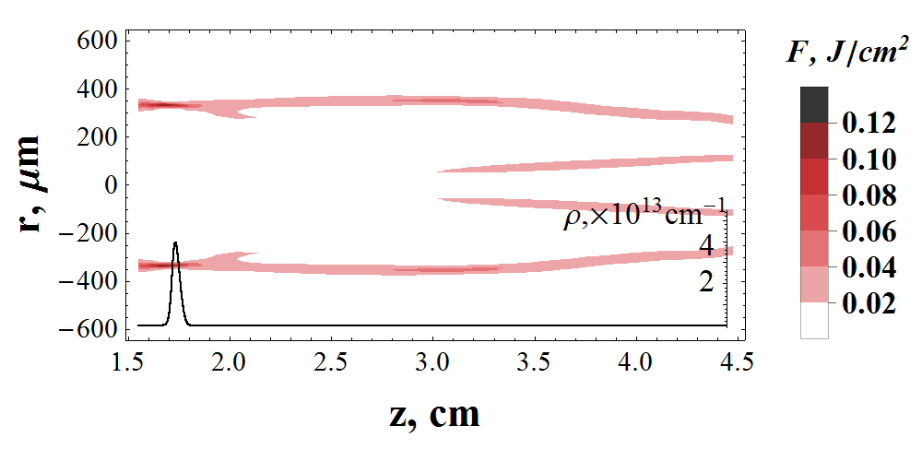
Fig. 1. Spatial distribution of fluence $F$ and linear plasma concentration $ρ$. Distance z calculates from the leading edge of crystal.

Anomalous group velocity dispersion (AGVD) at the beginning makes pulse to compress and move with group velocity at the carrier frequency. Pulse envelope maintains a Gaussian-like shape, while the beam has an annular structure. The formation of such cylindrical spatiotemporal structure is reinforced by the influence of AGVD, because it prevents pulse spreading making high frequencies propagate with group velocity greater than group velocity of lower frequencies in the pulse. Self-focused intensive annular part of the beam propagates in the medium with higher refractive index. This leads to the fact that it is shifted backwards in time relative to the initial center of the pulse. Simultaneously optical energy flows towards optical axis due to linear diffraction. The presence of a phase singularity in the beam prevents energy transformation directly to optical axis and, as a result, the second annular structure of smaller diameter appears at distance 3.2 cm. At the same time, radiation in outer ring refocuses. Tubular structure of the beam remains at least up to 4.5 cm, wherein outer and inner rings move towards each other.
In summary, we have presented the results of numerical calculations of optical vortex femtosecond filamentation in mid-IR based on mathematical model with slowly varying wave approximation. We have obtained and analyzed the spatio-temporal dynamics of pulse propagation and formation of tubular structure of the beam with pulse time compression due to anomalous group velocity dispersion.
This work has been supported by the Council of RF President, grant NSh-9695.2016.2.

- V.P. Kandidov, S.A. Shlenov, O.G. Kosareva, Quantum Electronics, 39, 3 (2009).
- A. Couairon, A. Lotti, P. Panagiotopoulos et al., Proc. of SPIE, 87701E (2013)
- S.V. Chekalin, A.E. Dokukina, A.E. Dormidonov, V.O. Kompanets, E.O. Smetanina, and V.P. Kandidov, Journal of Physics B: Atomic, Molecular and Optical Physics, 48, 9 (2015)
- P. Sprangle, E. Esarev, J Krall, Physics of Plasma, 3, 2183 (1996)
- E.V. Vasil’ev, S.A. Shlenov, Quantum Electronics, 46, 1002 (2016).
- L.T. Vuong, T.D. Grow, A. Ishaaya, A.L. Gaeta, Physical Review Letters, 96, 13 (2006)

