Type: Poster

Title: Age-related dependencies of aggregation properties of RBCs in healthy individuals and patients suffering from socially significant diseases

Authors: Marmylev A.S., Ermolinsky P.B., Umerenkov D.A., Dyachuk L.I., Lugovtsov A.E., Priezzhev A.V.

WORKSHOPS: OPTICAL TECHNOLOGIES IN BIOPHYSICS & MEDICINE XXV

Red blood cells (RBCs) are the primary cellular elements of blood performing several important functions in the body. RBCs are able to reversibly form 2D or 3D structures (aggregates), which significantly influence the blood circulation in the body. Studying the aggregation properties of erythrocytes is an essential task because it can provide insight into the state of blood and its ability to effectively transport oxygen. Aggregation properties of erythrocytes can change due to various factors, such as alterations in the protein composition of blood [1] and diseases [2]. However, currently, information about RBCs aggregation in patients of different age groups is limited. Therefore, investigating age-related changes in RBCs aggregation properties is an important task in assessing blood microcirculation.

The main goal of this work is to study the aggregation properties of erythrocytes in patients of different age groups suffering from arterial hypertension (AH) and atrial fibrillation (AF), as well as in healthy donors. All participants were divided into 6 groups: healthy donors younger 24 y/o (n = 17) and older 24 y/o (n = 5), AF patients younger 70 y/o (n = 24) and older 70 y/o (n = 43), AH patients younger 70 y/o (n = 48) and older 70 y/o (n = 28).

Measurements of RBCs microrheological parameters were conducted using the erythrocyte aggregometer RheoScan. The following parameters were determined based on the signal of diffuse light scattering from blood samples: the critical shear stress (CSS) - the minimum shear stress that must be applied to the flow of aggregates in order to break them down, and the aggregation index (AI) - the fraction of cells that aggregate within the first 10 seconds of the process of spontaneous aggregation.

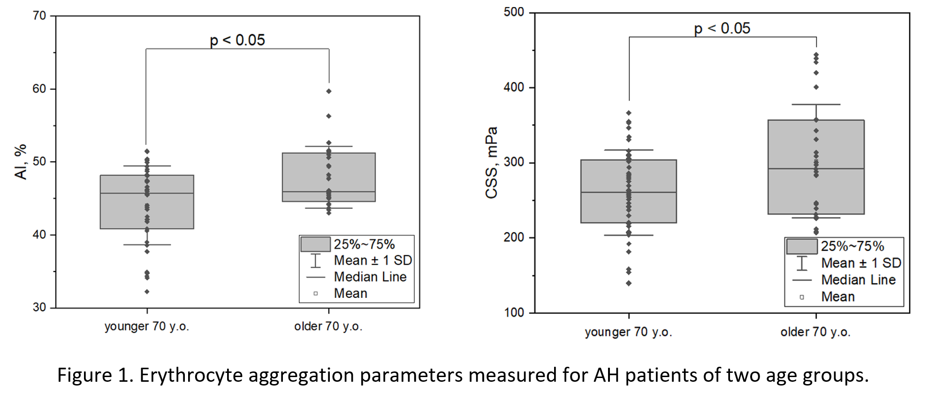

The results of the conducted research showed that the aggregation parameters, including the aggregation index and the critical shear stress, vary depending on the age of donors in all groups of participants, and these differences are statistically significant (p < 0.05). For example, in healthy donors younger 24 y/o, the CSS parameter was 200 ± 40 mPa, and the AI parameter was 40 ± 3%, while in healthy donors older 24 y/o, these parameters were 240 ± 30 mPa and 47 ± 7%, respectively. For AF patients younger 70 y/o, the CSS parameter was 240 ± 40 mPa, and the AI parameter was 49 ± 5%, while for patients older 70 y/o, these parameters were 270 ± 60 mPa and 52 ± 5%, respectively. For AH patients younger 70 y/o, the CSS parameter was 260 ± 60 mPa, and the AI parameter was 44 ± 5%, while for patients older 70 y/o, these parameters were 300 ± 70 mPa and 48 ± 4%, respectively. Some of the results are illustrated in figure 1. Based on the obtained data, we can conclude that RBCs aggregation parameters statistically significantly increase with age, leading to increased blood viscosity and changes in its microcirculation.

This work was performed with the support of MSU Development Program (project No 23-SCH06-03).

[1] Semenov A.N., Lugovtsov A.E., Li K., Fabrichnova A.A., Kovaleva Y.A., Priezhev A.V. "The use of methods of diffuse light scattering and optical trapping to study the rheological properties of blood: erythrocyte aggregation in diabetes" // Izvestiya of Saratov University. New Series. Series Physics, 2017, Vol. 17, No. 2, pp. 91-94 (in Russian).

[2] Korneev K.N., Ermolinsky P.B., Lugovtsov A.E., Priezzhev A.V. "Comparison of the influence of fibrinogen and gamma-globulin on erythrocyte aggregation in vitro" // Collection of materials of the international internet symposium "MICROCIRCULATION, BLOOD RHEOLOGY, AND OXYGEN HOMEOSTASIS", Yaroslavl’, 2022, pp. 229 – 235 (in Russian).