UDC 544
SURFACE MODIFICATION OF POWDER COMPOSITION "Al-C" WITH
3,3,3-TRIFLUOROPROPYLTRIMETHOXYSILANE
Bulatnikov D. A., Grafov O. Yu., Popov D. A.

The Institute of Physical Chemistry and Electrochemistry RAS (IPCE RAS)
119071 Moscow, Russia, bulatnikov@phyche.ac.ru

The work has demonstrated the possibility of obtaining an antioxidant protective coating on the particles of powder composition "Al-C" by modification with 3,3,3-trifluoropropyltrimethoxysilane from acetone solution. Quantitative ratios of element states on the sample surface were determined by XPS-spectroscopy.

Powder composition, mechanical alloying, modification, TFPTMS, protective coating

The method of mechanical alloying is a unique technique for obtaining energy-saturated compounds of heterogeneous components in the form of a powder [1]. To date powder compositions based on activated aluminum are of particular interest. Among them the system of "Al-C" composition is promising due to high energy release values in combination with the general availability of powder reagents and the simplicity of synthesizing the final material. At the same time, like the majority of aluminum-containing compositions, the system "Al-C" is sensitive to moisture, hence, for the possibility of practical application of the powder composition it is necessary to form a protective antioxidant coating on the activated particles.
The application of fluorine-containing coatings practically does not affect the value of the specific heat of combustion of the system, along with this it allows reducing the induction period.
Previously, it was shown in [2] that the near-surface layer of activated aluminum-containing powder compositions contains a significant content of hydroxide functional groups, the presence of which allows using alkoxysilanes as a modifier.
Thus, a 5% solution of 3,3,3 -trifluoropropyltrimethoxysilane (TFPTMS) in acetone was chosen to form a protective antioxidant coating. It is necessary to use only an anhydrous solvent that does not react with the modifier molecules to avoid hydrolysis of the alkoxysilane.
Figure 1 shows the mechanism of interaction of the modifier with the substrate surface.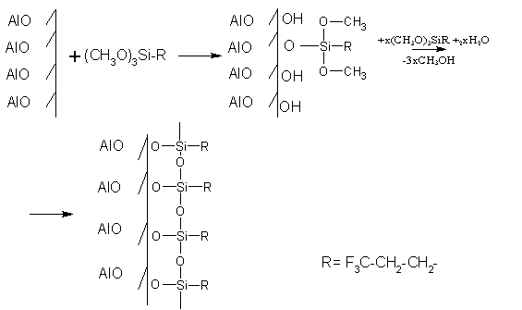

Figure 1 – Mechanism of interaction of fluorinated alkoxysilane with the oxidized surface of Al-C powder composition

As a result of the modification a system of Al-O-Si, Si-O-Si bonds is formed due to which the powder functionalization and protection against oxidation is provided.
The surface of the composite powder was studied by XPS spectroscopy. C1s-, O1s-, F1s-, Al2p- and Si2p-electron spectra were analyzed to study the qualitative and quantitative composition, but the most informative of them were the C1s- and O1s-electron spectra shown in the figure below.

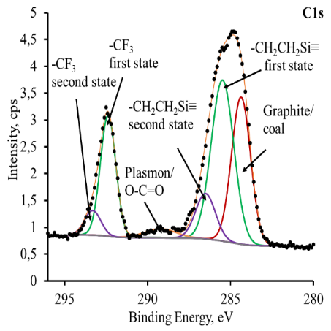 | 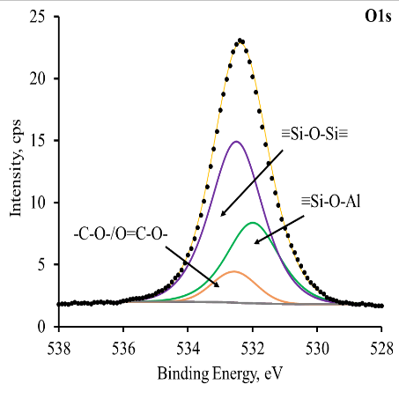
a | b
Figure 2 – XPS spectra of carbon C1s- (a) and oxygen O1s-electrons (b)

According to the results of XPS-research in the region of C1s-electrons carbon on the sample surface appears in several states: with 284.3 eV bond energy which can be correlated with graphite and coal, oxygen-containing derivatives -O-C=O with 289.1 eV bond energy and -C-O- and TFPTMS chain fragments: -CH₂-CH₂-Si- with 285.5 eV bond energy and -CF₃ with 292.4 eV bond energy. The appearance of an additional peak in the case of -CH₂-CH₂-CH₂- and -CF₃ is due to different surroundings of the atoms, leading to a change in the charge of the atoms due to redistribution of the electronic density on a number of molecules.
The oxygen O1s-electron spectrum is the most informative. It can be represented by a set of peaks, which can be correlated with the following states: the peak of a number of states: -C-O-, O=C-O, the -Si-O-Si- bond system in the energy region of 532.5 eV, and the -Si-O-Al bond system with an energy value of 532 eV. The presence of the peak responsible for the -Si-O-Al bond complex allows us to suggest the successful joining of TFPTMS on the surface of the composite powder.
Using the integral intensities under the peaks taking into account the cross sections of photoionization of electron shells, the ratios of the studied elements on the surface were calculated. It was shown that the quantitative content of the state responsible for the -Si-O-Al bond system is 6.74%, while, the content of the state responsible for the -CF₃ bond reaches 25.20%.
The results obtained testify to sufficiently high efficiency of TFPTMS for the possibility of its application as a surface modifier for composite powder of "Al-C".

REFERENCES
1. Koch C. C., Materials synthesis by mechanical alloying, Ann. Rev. Mater. Sci., 1989, Vol. 19, P. 121–143.
2. Bulatnikov D. A. Investigation of the compatibility of high-density energetic boron-containing composite powders with curable polymer matrices. Optimization of the physical and mechanical properties of the composite. Master’s thesis. MIREA - Russian Technological University (MITHT named after M. V. Lomonosov). Moscow. 2021. 86 c.

