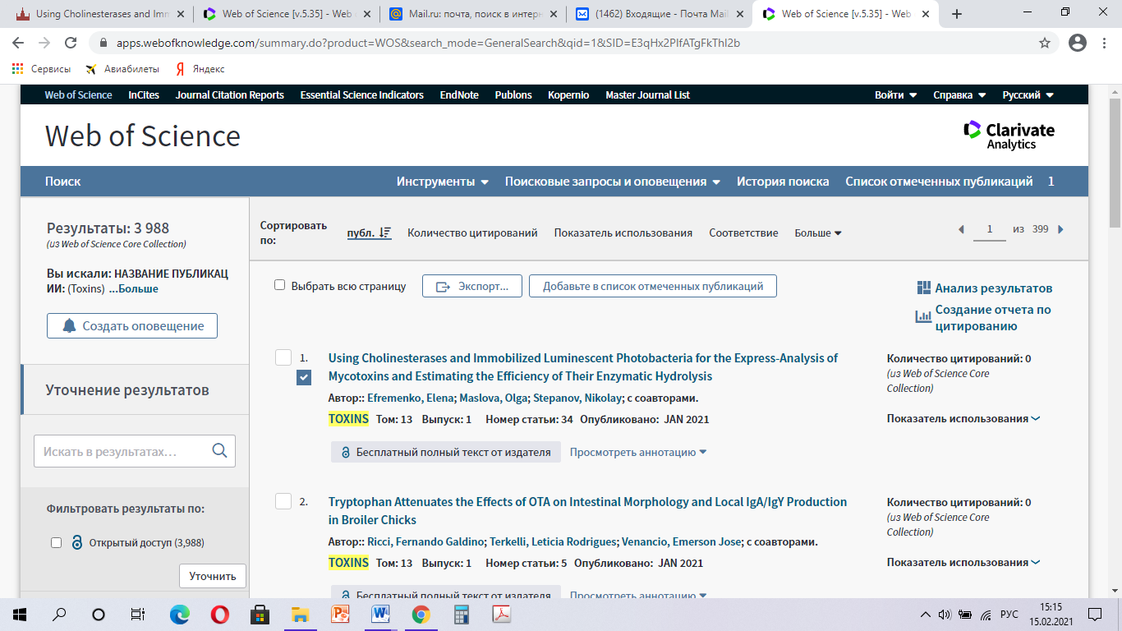

https://apps.webofknowledge.com/summary.do?product=WOS&search_mode=GeneralSearch&qid=1&SID=E3qHx2PlfATgFkThl2b