Non-destructive determination of thickness of the dielectric layers
using EDX

S. Sokolov, E. Kelm, R. Milovanov
Institute of Nanotechnology of Microelectronics, Russian Academy of Science, Russia, 119991 Moscow, Leninsky Prospekt, 32A, sokol481@rambler.ru

The importance of the thin films in semiconductor, microelectronics, photonics, microsystems and other engineering industries is well known. In this regard, the determination of thin film thicknesses is highly interesting challenge. Many different techniques can be used to measure the thickness of thin films [1].The main requirement for these methods is locality of measurements and also methods should be non-destructive. Energy dispersive X-ray spectroscopy (EDX) Spectroscopy satisfies these requirements. However, the existing methods for determining the thickness of thin films using EDX have several disadvantages [2].
In this work a non-destructive method for measuring the thickness of the dielectric layers consisting of silicon oxide and silicon nitride has been developed using a scanning electron microscope (SEM) equipped with energy dispersive X-ray spectrometer (EDS).
The main idea of our method consists in the following. An increase of accelerating voltage of electron beam leads to an increase in the depth of generation of the characteristic X-ray. If the signal intensity ratio of one of the substrate elements to the background equal to 3 suggests that the depth of generation of the characteristic X-ray coincides with the thickness of the overlying film. Dependence of the thickness of the overlying film on the accelerating voltage may be plotted (fig.1a).
Validation of the results was carried out using the Bette equation (1):
$$R=\frac{\text{27}\text{.}6{\text{AE}}_{0}^{1\text{.}\text{67}}}{{ρZ}^{0\text{.}\text{89}}}$$ | (1)
The volume of generation of the characteristic X-Ray was simulated using a CASINO program [3] (fig.1b). The simulations are in good agreement with the experimental results for small thicknesses.
Thickness determination carried out on samples of integrated circuits PIC16F876A. Samples were treated in RIE (reactive ion etching) to reduce the thickness of the dielectric layers. Cross-section (fig.1c), performed using FIB (focused ion beam), and SEM images were used to confirm thickness of the dielectric layers after RIE.
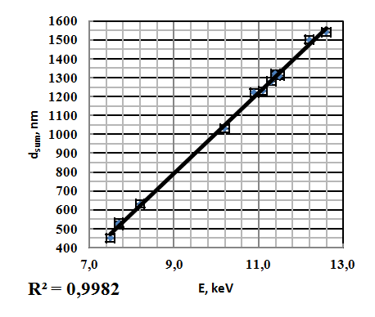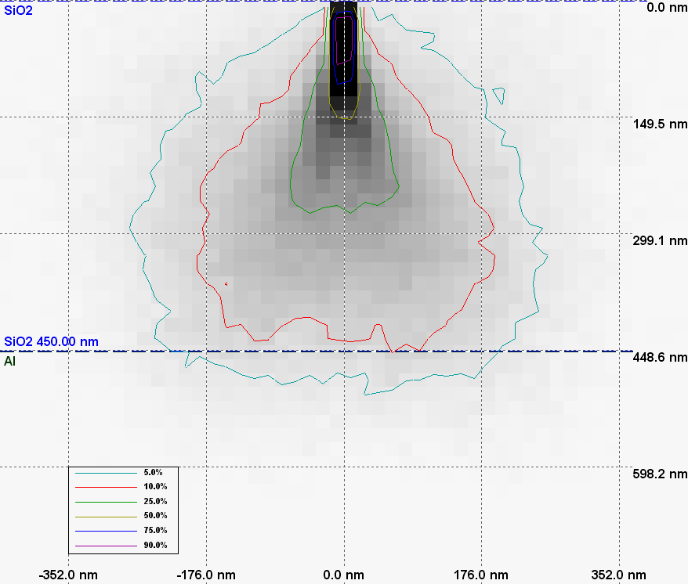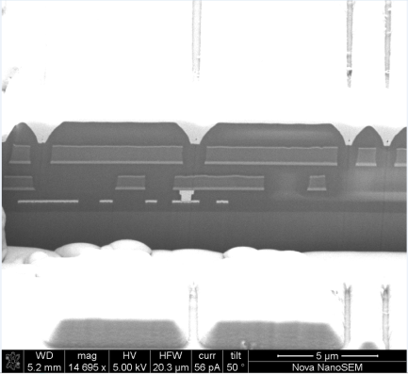
a) b) c)
Fig.1. Calibration curve (a), results of simulation in Monte-Carlo program (b) and SEM image of cross-section PIC16F876A (c).

1 A. Piegari and E. Masetti, “Thin film thickness measurement: a comparison of various techniques,” Thin Solid Films, 124, pp. 249-257, 1985.
2. G. Love, W. A. Nicholson, A. Armigliato. Modern Developments and Application in Microbeam Analysis. Springer, New York, 1998.
3. P. Hovington, D. Drouin, R. Gauvin. "CASINO : A New Monte Carlo Code in C Language for Electron Beam Interaction —Part I: Description of the Program". Scanning, 19, pp. 1-14, 1997.

