*ISSN 1061-933X, Colloid Journal, 2020, Vol. 82, No. 2, pp. 130–135. © Pleiades Publishing, Ltd., 2020. Russian Text © The Author(s), 2020, published in Kolloidnyi Zhurnal, 2020, Vol. 82, No. 2, pp. 171–176.*

Inversion of Montmorillonite Ion-Exchange Characteristics

**T. V. Kon’kova*a*, * and A. P. Rysev*a***

*aMendeleev University of Chemical Technology of Russia, Moscow, 125480 Russia*

***\*****e-mail:* [*kontat@list.ru*](mailto:kontat@list.ru)

Received July 17, 2019; revised August 20, 2019; accepted August 26, 2019

**Abstract**—The mechanism of montmorillonite modification with sodium metasilicate for inversing its ion- exchange characteristics has been studied. The blockage of the interlayer space in montmorillonite by amor- phous silicon–oxygen clusters, which are formed as a result of sodium metasilicate hydrolysis, hinders the access of ions to the internal negatively charged surface of the mineral and increases the strength of bonding between aluminosilicate layers. As a result, adsorption becomes possible only on the outer surface of particles, namely, on active silanol and aluminol groups. This fact has been confirmed by the high rate of the process, as well as by the appearance of the ability to adsorb anions only after the reversal of montmorillonite surface charge. The value of the adsorption of Cr(VI) oxoanions by modified montmorillonite has appeared to be 0.26–1.05 mg/g depending on the synthesis conditions of the samples.

**DOI:** 10.1134/S1061933X20020064

INTRODUCTION

A natural layered aluminosilicate, montmorillon- ite, contains two groups of active sites, which give it the ability to adsorb both cations and anions [1]. Cat- ion adsorption occurs by the ion-exchange mecha- nism via the replacement of interlayer alkali or alka- line-earth metal cations, which neutralize the negative charge of aluminosilicate layers, by an equivalent amount of adsorptive cations [2–4]. The negative charge of the internal surface results from the isomor- phic replacement of aluminum by a metal with a lower valence in the structure of the three-layer stacks of the mineral.

Anion adsorption by montmorillonite is potentially possible due to the presence of aluminol and silanol groups on the lateral surfaces of the aluminosilicate layers (Fig. 1). These groups may carry negative or positive charges depending on the pH of a medium [5]. Owing to the ability of interlayer cations to be hydrated, the interlayer distance increases and mont- morillonite particles are delaminated in an aqueous medium into elementary aluminosilicate layers or their aggregates. The area of the lateral faces of the particles is small as compared with the area of the basal negatively charged surface, which becomes easily accessible for an adsorptive after the delamination. As a result, the montmorillonite particle surface carries a negative total charge even at low pH values, with anions being repelled from it in this case [6, 7].

The substitution of interlayer inorganic cations of montmorillonite by organic cations of quaternary ammonium salts may lead to surface hydrophobiza- tion and a decrease in the delamination of particles in

water [8]. The simultaneous hindrance of the access to the interlayer space by modifier molecules results in the fact that only the external surface containing sila- nol and aluminol groups remains accessible for an adsorptive. The surface charge of montmorillonite modified in this way is reversed for the positive one, and the material becomes capable of adsorbing anions [9–11]. A drawback of this modification method is the instability of the organomineral structure of the adsor- bent caused by a gradual washing of the organic mod- ifier from it into a solution [8, 11].

The authors of [12] have stated that pillared struc- tures, in which silicon–oxygen columns, which have a chemical structure similar to the T-networks of three- layer stacks of clay and can protect montmorillonite from delamination by strongly bonding the aluminos- ilicate layers with each other, must be substantially more stable.

In this work, we have studied the possibility to hin- der the access of an adsorptive to the internal nega- tively charged montmorillonite surface by filling its interlayer space with amorphous silica gel using con- centrated sodium metasilicate solutions instead of dilute ones, as well as suspensions with high SiO2-to- montmorillonite ratios. The aim of this work was to synthesize and study a montmorillonite-based adsor- bent possessing anion-exchange properties.

EXPERIMENTAL

Natural aluminosilicate from the Taganskoe deposit (Kazakhstan) with a montmorillonite content of 90% was used as the object for modification.

130

O O O OH

Si Si

O O O OH

Si Si

O O O OH

Si Si

O O OH+ O

Al

Al

Al

Al

2

O OH O

O O2–

O O

Si Si

O O O

OH+

OH

2

O O OH

Si Si

O O O OH

O O

Al

Al

Si Si

O O O

OH

O2–

4 5 6 7 8 9 10

pH

**Fig. 1.** Charges of silanol/aluminol groups on the lateral surface of aluminosilicate layers as depending on pH.

To carry out the modification, weighed portions of clay with particle sizes of <500 m were mixed with aqueous 5–20 wt % sodium metasilicate solutions. The content of SiO2 in the mixtures with montmoril- lonite was varied from 10 to 80 wt %. The suspensions were stirred for 2–5 h at 20 or 60C. The solid phase separated from the sodium metasilicate solution was washed twice with distilled water and exposed in an H2SO4 solution with pH 1 or 5.5. The solid phase-to- acid ratio was 1 : 25 in all cases. Sample А was addi- tionally washed with water after the acidic treatment. The material was aged in air for 12 h at room tempera- ture and calcined for 3 h at *T*calc = 200 or 400C. The conditions for the preparation of the samples are pre- sented in Table 1. Sample C was calcined immediately after the acidic treatment. To prepare sample M, the initial aluminosilicate was exposed to mechanical acti- vation in a laboratory mill for 20 min.

The textural parameters of the obtained samples were determined from isotherms of nitrogen adsorp- tion measured at 77 K with a Nova 1200e setup (Quan-

tachrome, United States). Specific surface areas *S*BET of the initial montmorillonite and its modified sam- ples were calculated using the BET method, while micropore volume *V*mi was calculated by the Dubinin– Radushkevich equation. Total volume *V*s of meso- and micropores was determined from the isotherm of nitrogen adsorption at a relative pressure of 0.995.

The surface electrokinetic potentials of the parti- cles of the initial montmorillonite and the modified samples were measured by electrophoresis with a Zetasizer Nano instrument (Malvern Instruments, United Kingdom) in aqueous suspensions with a solid phase concentration of 0.5 g/L.

The cation-exchange capacity of the samples was measured using the exchange reaction with copper complex of ethylenediamine [Cu(en)2]2+ at pH 8 in a tris(hydroxymethyl)aminomethane–HCl (0.9 : 1)

buffer solution [13].

The X-ray diffraction analysis was carried out with a D8 ADVANCE diffractometer (Bruker AXS, Ger- many) operating at a tube voltage of 40 kV and a cur-

**Table 1.** Conditions of montmorillonite modification with sodium metasilicate

|  |  |  |  |  |  |  |  |  |  |  |  |  |  |
| --- | --- | --- | --- | --- | --- | --- | --- | --- | --- | --- | --- | --- | --- |
| Samples | A | B | C | D | E | F | G | H | I | J | K | L | M |
| *C*Na2SiO3 , wt % | 20 | 20 | 20 | 20 | 20 | 20 | 20 | 20 | 20 | 20 | 10 | 5 | 20 |
| SiO2, wt % | 80 | 80 | 80 | 80 | 80 | 80 | 80 | 80 | 30 | 10 | 80 | 80 | 80 |
| *t*mod, h | 2 | 2 | 2 | 2 | 2 | 2 | 2 | 5 | 2 | 2 | 2 | 2 | 2 |
| *T*mod, C | 20 | 20 | 20 | 20 | 20 | 20 | 60 | 20 | 20 | 20 | 20 | 20 | 20 |
| Washing no. 1 | Yes | Yes | Yes | Yes | Yes | No | Yes | Yes | Yes | Yes | Yes | Yes | Yes |
| рН of acid | 1 | 1 | 1 | 1 | 5.5 | 1 | 1 | 1 | 1 | 1 | 1 | 1 | 1 |
| Washing no. 2 | Yes | No | No | No | No | No | No | No | No | No | No | No | No |
| Ageing | Yes | Yes | No | Yes | Yes | Yes | Yes | Yes | Yes | Yes | Yes | Yes | Yes |
| *T*calc, C | 200 | 200 | 200 | 400 | 200 | 200 | 200 | 200 | 200 | 200 | 200 | 200 | 200 |

**Table 2.** Adsorption of Cr(VI) oxoanions by initial and modified montmorillonite samples at different pH values

|  |  |  |  |  |  |  |  |
| --- | --- | --- | --- | --- | --- | --- | --- |
| Sample | Adsorption, mg/g | | | Sample | Adsorption, mg/g | | |
| рН 3 | рН 7 | рН 10 | рН 3 | рН 7 | рН 10 |
| Initial | 0.07 | 0 | 0 | G | 1.07 | 0.84 | 0.61 |
| А | 0.39 | 0.31 | 0.21 | H | 0.84 | 0.79 | 0.42 |
| B | 1.24 | 0.98 | 0.69 | I | 0.43 | 0.34 | 0.24 |
| C | 0.47 | 0.39 | 0.28 | J | 0.41 | 0.33 | 0.25 |
| D | 0.8 | 0.68 | 0.47 | K | 0.68 | 0.57 | 0.46 |
| E | 0.12 | 0 | 0 | L | 0.54 | 0.42 | 0.35 |
| F | 0.29 | 0.26 | 0.23 | M | 1.38 | 1.05 | 0.91 |

**Table 3.** Textural parameters of initial and modified montmorillonite samples

|  |  |  |  |  |  |  |  |
| --- | --- | --- | --- | --- | --- | --- | --- |
| Sample | *S*BET, m2/g | *V*s, cm3/g | *V*mi, cm3/g | Sample | *S*BET, m2/g | *V*s, cm3/g | *V*mi, cm3/g |
| Initial | 73.6 | 0.075 | 0.035 | 2.8 | 0.010 | 0.002 | 2.8 |
| А | 10.8 | 0.037 | 0.004 | 6.1 | 0.021 | 0.002 | 6.1 |
| B | 2.8 | 0.013 | 0.001 | 14.4 | 0.035 | 0.006 | 14.4 |
| C | 19.7 | 0.049 | 0.008 | 14.9 | 0.014 | 0.007 | 14.9 |
| D | 14.9 | 0.029 | 0.006 | 7.16 | 0.018 | 0.003 | 7.16 |
| E | 49.4 | 0.056 | 0.022 | 8.9 | 0.028 | 0.004 | 8.9 |
| F | 17.1 | 0.023 | 0.006 | 2.7 | 0.011 | 0.001 | 2.7 |

rent intensity of 30 mA using Cu*K* radiation ( = 1.5418 Å) in an angle range of 2 = 5–30 with a step of 0.0074.

IR spectra of the samples were recorded using a Nicolet 380 Fourier-transform spectrometer (Thermo Fisher Scientific Inc., United States) in a range of 4000–400 cm–1. The resolution of the instrument was 4 cm–1, and the number of scans was 32.

The elemental analysis of the samples was carried out with an INCA Energy Analyzer setup (Oxford Instruments) by the X-ray f luorescence method.

The adsorption capacity of clay samples with respect to anions was studied by the example of Cr(VI) oxoanions. Each sample (0.1 g) was placed into an aqueous potassium bichromate solution (25 mL) with an initial Сr(VI) concentration of 5 mg/L. After the adsorption, the Cr(VI) oxoanion content in the solu- tion was determined spectrophotometrically on the basis of the light absorption of colored chromium– 1,5-diphenylcarbazide complex at a wavelength of 540 nm [15].

RESULTS AND DISCUSSION

Almost all sodium-metasilicate-modified mont- morillonite samples have become capable of anion adsorption in contrast to the initial mineral (Table 2). The adsorption of Cr(VI) oxoanions depends on the pH of a medium. The adsorption value increases with

a decrease in pH, and vice versa. This indicates that adsorption sites are represented by silanol and alumi- nol groups located on the external lateral surface of aluminosilicate layers, because they are the only pH- dependent sites in montmorillonite.

Adsorption on the external surface of montmoril- lonite has also been confirmed by the textural param- eters of the modified samples, with these parameters being significantly decreased relative to the initial ones (Table 3). Worsening of the texture, namely, a signifi- cant decrease in the micropore volume, is caused by the formation of silicon–oxygen clusters, which block the interlayer space of montmorillonite particles as a result of their treatment with sodium metasilicate.

Were the ion adsorption realized on the internal surface of montmorillonite, its rate would be insignif- icant due to a strong drag to the internal diffusion. However, the rate of adsorption is high (Fig. 2) and the adsorption equilibrium is established 15–20 min after the phases are brought in contact. In addition, the value of adsorption on modified montmorillonite increases with a decrease in the textural parameters of modified montmorillonite. Hence, the adsorption capacity of montmorillonite with respect to anions increases with the degree of shielding of the internal negatively charged surface for an adsorptive.

The ability of modified montmorillonite samples to adsorb anions is related to the magnitude and sign of the surface electrokinetic potential of their particles

Adsorption of Cr(VI) oxoanions, mg/g 1.4

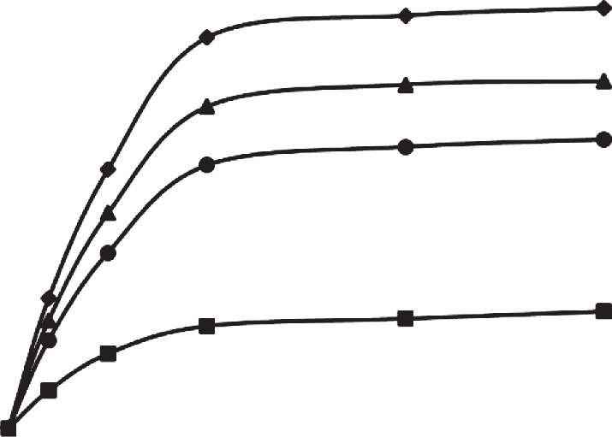

*4*

*3*

*2*

*1*

1.2

1.0

0.8

0.6

0.4

0.2

Intensity

5

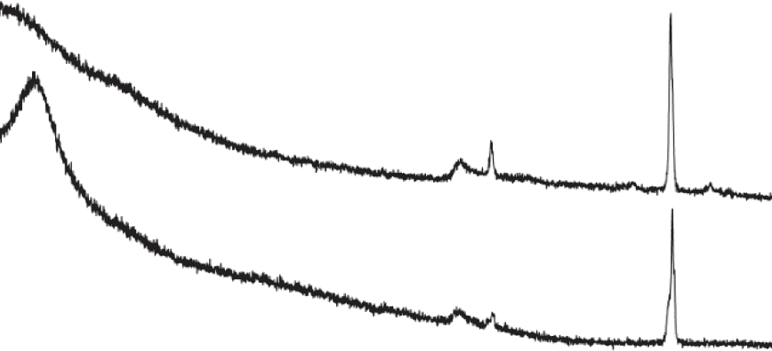

*2*

*1*

10 15 20 25

30

2, deg

0 5 10 15 20 25 30 35

Time, min

**Fig. 2.** Kinetic curves for adsorption of Cr(VI) oxoanions on different samples of modified montmorillonite: (*1*) I, (*2*) G, (*3*) B, and (*4*) M.

(Table 4). Cr(VI) oxoanions are adsorbed only by the samples, the surface charge of which has been reversed.

There is a correlation between a change in the tex- tural parameters of modified montmorillonite and the value/sign of the surface electrokinetic potential of its particles. The lower these parameters, the higher the positive shift of the -potential.

The X-ray diffraction data (Fig. 3) have shown that the modification of montmorillonite leads to an increase in the interplanar (interlayer) distance, which is accompanied by a shift of the characteristic peak at 2 = 6.5 toward smaller angles. This tendency is typ- ical of all modified samples. The absence of new dif- fraction peaks in the diffraction patterns of the modi- fied samples indicates that the formed silicon–oxygen clusters are amorphous. This enables us to explain the dependence of the anion adsorption on the sample synthesis conditions from the point of view of the sol- gel synthesis of silica gel. The diffraction peak at 2 =

**Table 4.** Surface electrokinetic potentials of particles of ini- tial and modified montmorillonite samples at рН 7

|  |  |  |  |
| --- | --- | --- | --- |
| Sample | -Potential, mV | Sample | -Potential, mV |
| Initial | –23.8 | G | +4.9 |
| А | +1.8 | H | +3.7 |
| B | +6.9 | I | +3.1 |
| C | +2.5 | J | +1.7 |
| D | +4.6 | K | +3.6 |
| E | –11.8 | L | +2.9 |
| F | +0.8 | M | +10.7 |

**Fig. 3.** X-ray diffraction patterns of (*1*) initial montmoril- lonite and (*2*) modified sample B.

26.7 corresponds to the presence of quartz impurity in the natural aluminosilicate.

The adsorption capacity of modified montmoril- lonite with respect to anions increases with the con- centration of a modifying sodium metasilicate solu- tion (compare samples B, K, L, and M), as well as SiO2 content in the mixture with the clay (compare samples B, I, J, and M). Hence, the higher the content of the “blocking” agent, the higher the extent of shielding of the internal negatively charged aluminos- ilicate surface and, accordingly, the higher the adsorp- tion capacity with respect to anions. The duration and temperature of montmorillonite treatment with a sodium metasilicate solution (within the studied range of these parameters) do not affect significantly the final result (compare samples B, G, and H). Duration of two hours seems to be sufficient for filling the pore space of montmorillonite with a sodium metasilicate solution. It should also be noted that an increase in modification time *t*mod and temperature *T*mod promote the delamination of the mineral particles.

The montmorillonite–sodium metasilicate sus- pension has pH 11. The acidic treatment of the mate- rial without preliminary washing (rapid decrease in pH) leads to the formation of numerous nuclei of a new solid phase, which, however do not have time to grow; as a result, large pores of montmorillonite are not blocked to the full extent (F sample).

When the pH is decreased to 5.5 without subse- quent acidic treatment (sample E), relatively large sil- ica gel particles are formed, which cannot block mont- morillonite micropores. It is also known that mont- morillonite point of zero charge lies in the neutral pH region [5], and a decrease in pH to 5.5 does not result in the protonation of the external silanol and aluminol groups.

Hence, the pH should be reduced stepwise; first, by washing the material and, then, by the acidic treat-

1 ment. As a result, silica gel nanoparticles with different diameters (1–20 nm) are formed, which block the entire interlayer space of montmorillonite. The sam- ples washed before the acidic treatment adsorb Cr(VI) oxoanions most efficiently.

The importance of the ageing stage of modified montmorillonite is explained by the phenomenon of syneresis, during which the final structure of silicon– oxygen clusters is formed (compare samples B and C).

The higher the dispersity of clay particles, the larger the fraction of their total surface area, which belongs to the aluminol- and silanol-group-contain- ing lateral faces of aluminosilicate layers. Hence, of

Intensity

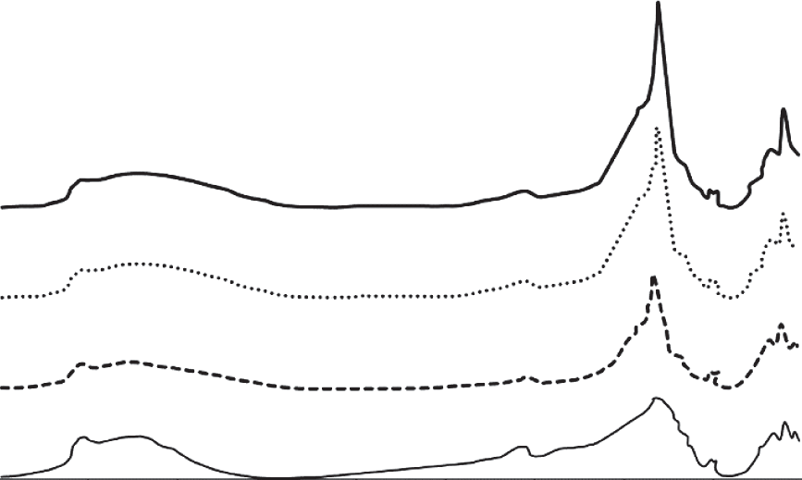

*4*

*3*

*2*

*1*

4000 3600 3200 2800 2400 2000 1600 1200 800 400

the refinement of particles (in our case, mechanical activation) is advantageous (compare samples B and M).

The IR spectra (Fig. 4) of the initial and modified samples show a number of bands, which are typical for montmorillonite, as well as concomitant impurities [14, 15]. A weak band at 797 cm–1 corresponds to quartz impurity. The bands at 3430 cm–1 (stretching vibrations of Н–О–Н groups) and in the vicinity of 1642 cm–1 (bending vibrations of Н–О–Н groups) are attributed to adsorbed water. Their intensity decreases in the spectra of all modified samples upon thermal dehydration. A broad band with a maximum at 3630 cm–1 corresponds to the stretching vibrations of Al,Mg–OH. Its intensity somewhat decreases after the modification as a result of the acidic treatment of the mineral [16]. The main changes in the spectra of the modified samples are observed at 1040 cm–1 (stretching vibrations of Si–O), 520 cm–1 (bending vibrations of Al–O–Si), and 466 cm–1 (bending vibra- tions of Si–O–Si). The intensities of these bands in all modified samples are increased as compared with the initial aluminosilicate. These changes are caused by the formation of silicon–oxygen clusters in the inter- layer space of montmorillonite, with the structure of the clusters being similar to the Si–O–Si tetrahedrons of montmorillonite. The intensity of aforementioned bands increases with the concentration of sodium metasilicate solution and its content in the system.

A characteristic feature of modified montmoril- lonite samples is a decrease in their cation-exchange

Wavenumber, cm–1

**Fig. 4.** IR spectra of (*1*) initial montmorillonite and differ- ent modified samples: (*2*) I, (*3*) B, and (*4*) M.

capacity relative to the initial mineral (Table 5), and the lower the values of the textural parameters, the stronger the decrease.

According to the elemental analysis data, the total content of exchangeable cations (Ca + Na) remains almost unchanged after the modification (nearly

1.20 wt %), thereby being indicative of their blockage in the interlayer space of montmorillonite with the sil- icon–oxygen clusters.

Thus, the ion-exchange characteristics of mont- morillonite are inverted as a result of the treatment with a sodium metasilicate solution.

CONCLUSIONS

Montmorillonite treated with a concentrated sodium metasilicate solution is able to adsorb anions, with this ability being caused by a redistribution of their access to different types of the mineral surface. Its internal negatively charged surface is blocked by amorphous silicon–oxygen clusters formed in the interlayer space during the modification. The external lateral surface of aluminosilicate layers, which con- tains aluminol and silanol groups acting as adsorption sites, remains accessible for anions. These conclusions

**Table 5.** Cation-exchange capacities of initial and modified montmorillonite samples

|  |  |  |  |
| --- | --- | --- | --- |
| Sample | Cation-exchange capacity, cmol/kg | Sample | Cation-exchange capacity, cmol/kg |
| Initial | 82 | G | 14.6 |
| А | 29.4 | H | 19.0 |
| B | 6.8 | I | 31.7 |
| C | 21.8 | J | 35.6 |
| D | 11.4 | K | 12.2 |
| E | 68.4 | L | 14.8 |
| F | 44.8 | M | 5.6 |

have been confirmed by the high rate of adsorption, the dependence of the adsorption value on pH, and the ability of montmorillonite to adsorb anions only after the reversal of its surface electrokinetic potential from the negative to the positive one.

ACKNOWLEDGMENTS

We are grateful to the Center for Collective Use of the Mendeleev University of Chemical Technology of Russia for help in the measurement of the IR spectra and the implementation of elemental analysis.

CONFLICT OF INTEREST

The authors declare that they have no conflict of inter-

est.

REFERENCES

1. Schoonheydt, R.A. and Johnston, C.T., in *Handbook of Clay Science*, Vol. 1, Bergaya, F., Theng, B.K.G., and Lagaly, G., Eds., Elsevier, France, 2006.
2. Ijagbemi, C.O. and Dong-Su, K., *Environ. Eng. Res.*, 2009, vol. 14, no. 1, p. 26.
3. Ihaddadene, B., Sehkri, L., Tifouti, L., Al- Dujaili, A.H., and Gherraf, N., *J. ChemTech Res.*, 2016, vol. 9, p. 667.
4. Gu, S., Kang, X., Wang, L., Lichtfouse, E., and Wang, C., *Environ. Chem. Lett.*, 2019, vol. 17, p. 629.
5. Lagaly, G., in *Handbook of Clay Science*, Vol. 1, Berga- ya, F., Theng, B.K.G., and Lagaly, G., Eds., Elsevier, France, 2006.
6. Fil, B.A., *Özmetin*, C., and Korkmaz, M., *Bulg. Chem. Commun.*, 2014, vol. 46, p. 258.
7. Lin, S.-H. and Juang, R.-S., *J. Hazard. Mater.*, 2002, vol. 92, p. 315.
8. Kon'kova, T.V., Rysev, A.P., and Mishchenko, E.V.,

*Perspekt. Mater.* (in press).

1. Sarkar, B., Xi, Y., Megharaj, M., Krishnamurti, G.S.R., Rajarathnam, D., and Naidu, R., *J. Hazard. Mater*., 2010, vol. 183, p. 87.
2. Muir, B., Andrunik, D., Hyla, J., and Bajda, T., *Appl. Clay Sci.*, 2017, vol. 136, p. 8.
3. Atia, A.A., *Appl. Clay Sci.*, 2008, vol. 41, p. 73.
4. Komarov, V.S. and Besarab, S.V., *Adsorbenty i nositeli katalizatorov. Nauchnye osnovy regulirovaniya poristoi struktury* (Adsorbents and Catalyst Supports. Scientific Fundamentals of Porous Structure Control), Moscow: INFRA-M, 2018.
5. Ammann, L., Bergaya, F., and Lagaly, G., *Clay Miner.*, 2005, vol. 40, p. 441.
6. Plyusnina, I.I., *Infrakrasnye spektry mineralov* (Infrared Spectra of Minerals), Moscow: Mosk. Gos. Univ., 1977.
7. Chukanov, N.V., *Infrared Spectra of Mineral Species*, New York: Springer, 2014.
8. Temuujin, J., Jadamba, Ts., Burmaa, G., Erdene-chi- meg, Sh., Amarsanaa, J., and Mackenzie, K.J.D., *Ce- ram. Int.*, 2004, vol. 30, p. 251.

*Translated by A. Muravev*

SPELL: 1. OK