THE CHINESE DIASPORA IN THE EU COUNTRIES

N. A. Sluka¹

A. V. Korobkov2

P. N. Ivanov¹

¹ Lomonosov Moscow State University

Leninskie Gory, Moscow, 119991 Russia

² Middle Tennessee State University

1301 East Main Street, Murfreesboro, TN 37132, USA

Submitted on May 13, 2018

doi: 10.5922/2078-8555-2018-3-5

© Sluka N. A., Korobkov A. V., Ivanov P. N., 2018

This article is a further contribution to the discourse of ethnic ‘diffusion’ in European countries. The debate started on the pages of the Baltic Region journal by three authors — Yu. N. Gladky, I. Yu. Gladky, and K. Yu. Eidemiller [4]. We assume that Europe has been a major centre of attraction for immigrants in recent decades and a site for the rapid emergence of ethnic communities. Unlike Muslim immigration, a product of the Arab Spring and often a measure of last resort, Chinese immigration is a result of a certain convergence between the ideologies of the host countries, committed to multiculturalism, and the country of origin pursuing a ‘go global’ policy. We chose the EU countries as a ‘demonstration site’ and the Chinese diaspora as the object of research. Our aim is to describe the process of migration from China and the formation of a Chinese diaspora in European countries. We analyse the timeline and the scope of Chinese immigration, qualitative changes in the composition of immigrants, factors affecting the choice of the country of entry, and the quantitative parameters and settlement patterns of today’s Chinese diaspora in the region. We suggest grouping the EU Countries by the number and ‘age’ of their Chinese diasporas. We consider ethnic ‘diffusion’ as part of the ‘European project’ within Beijing’s global strategy.

Keywords: ethnic diffusion, new migrants, Chinese diaspora, EU countries

An integral part of the globalisation process, international migration became an easily observable phenomenon at the end of the 20th century. As of 2015, according to the UN data, there were over 245 million people living outside their country of origin,[1] which is approximately 3% of the world’s population [25]. Obviously, the influence of the ‘migrant nation’ on political, social, demographic, and economic development of individual countries, as well as on intergovernmental collaborations and integration processes, is growing. The increase in irregular migration and the formation of ethnic communities tend to aggravate a whole range of problems. These include ‘erosion’ of the pillars of national cultures, replacement of the native populations by migrants, growing xenophobia, overloading of the labour market and the social security system, brain drain, security threats (including those of terrorist attacks), increased crime and corruption rates, etc. Recently, the issue of migration has merited close attention of international organisations, governmental circles from different countries, academic communities, and general public [2, 5, 11, 13, 24].

One of the largest migration systems in the world, Europe is being tested in the crucible of mass migration [10]. In 2015, the number of new arrivals was estimated at 1.5 million only in the EU. For 2016, the estimate was at 1.8 million people (fig. 1). With looming economic downturn and ethnic tensions, many countries of the region imposed strict control over migration and retargeted their migration policies at receiving qualified specialists at the expense of all the other categories of migrants, including refugees. During his time in office, Nicolas Sarkozy stressed the need to move from ‘suffered’ to ‘chosen’ migration [26, р. 17]. Although the political elite has gained a better understanding of the gravity of the problem, few practical measures have been taken. This results in ‘a rapidly growing criticism of the migration policy in Europe. The problem cannot be reduced to migration and minorities. They are not synonyms of poverty, unemployment, and aggression – which, for instance, Britons view as the cause of riots in their cities provoked by the so-called chavs. Crises also affect members of the middle class, thus widening the gap between them and the upper class. This does not eliminate the question about strategies for integration, adaptation, multiculturalism, focal or dispersed ethnic settlement pattern. Nor does it eliminate the question about social stratification or the absence thereof’ [18, p. 11]. The temptation of multiculturalism remains a headache for both Western European governments and the advocates of multicultural understanding and tolerance [4, p. 45]. Before the beginning of an emergency EU summit on migration scheduled for June 2018, the President of France Emmanuel Macron emphasised that migrant crisis in the EU had grown into a political crisis [14].

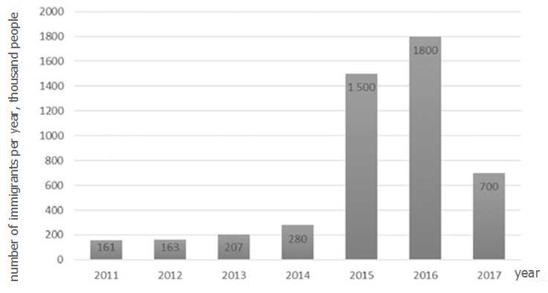

Fig. 1. Migrants in the EU, 2011–2017

Data compiled based on [20].

**‘Two sides of the same coin’, or the timeline of Chinese migration in Europe**

Against the backdrop of an unprecedented increase in migration in the region in the aftermath of the Arab Spring, few studies pay attention to migration from China. Works focusing on the geographical aspect are either absent or unknown to us. To a degree, this is explained by the history of the process, which can be perceived and evaluated from two perspectives – those of the country of origin and the country of destination. In terms of scale, direction, and structure, Chinse migration is divided into two distinct eras. The first era comprises three periods. The first period – from antiquity to the 19th century – is characterised by the relatively modest Chinese migration to the neighbouring countries, primarily those of South-East Asia. The period spanning the 19th century, the fall of the Qin dynasty, the substantial weakening of China, and the foundation of the People’s Republic of China in 1949, was marked by a considerable expansion of the geography of migration, its main channel being the coolie trade. In the next three decades – from 1949 to 1978 – migration was almost non-existent, since the country’s borders were closed at the time. The second era began as China embarked on economic reforms in 1978. Few have paid attention to the fact that almost half of today’s Chinese diaspora migrated from the country after this landmark event. The emergence of the so-called ‘new’ migrants dramatically affected the existing diasporas and the perception of the Chinese across the world. Such migrants have made a significant contribution to the development of China. They became a major force behind Chinese modernisation and an important link between the PRC and the rest of the world [17].

Despite its geographical remoteness, the European continent has attracted the Chinese population for a long time. Experts distinguish three stages of Chinese migration to the region. The first stage – from the late 19th to the mid-20th century – is characterised by sporadic arrivals of the Chinese and the emergence of small diasporas in Western European countries, mostly those with a colonial past. Having come by sea, most migrants settled in port cities. Others were arriving by land via Russia. The only period of a massive influx of migrants from China spanned the first years of the First World War, as European countries faced workforce shortage. The native population of Great Britain and France often viewed such migrants as a ‘national threat’. After the end of the war, most Chinese migrants were repatriated. During this period, Chinese migrants founded small Chinese quarters – ethnic enclaves, Chinatowns – in many large cities. The second stage (from the mid-20th century to the 1980s) witnessed an increase in the number of Chinese migrants, accounted for by the undocumented migration from the PRC during the Cultural Revolution and secondary migration influxes from Asia.[2] At the time, the Chinese appeared in the countries of Central Europe and occupied their own economic niche – the restaurant business [32]. The third, current, stage, is a product of a historical coincidence, when the second era of Chinese migration met liberalisation of migration laws in European countries aimed to attract international human resources. The distinctive features of the period are massive Chinese migration and the emergence of Eastern European states as likely destinations. The new wave is unique in terms of the gender distribution, high proportion of young people and qualified specialists, and the large contribution of educational migration. Of more than 2.6 million Chinese students who obtained higher education abroad, only 1.1 million (41.9%) returned home. In 2011, 339 thousand Chinese students were studying at universities across the globe [21, 30].

According to Ernst G. Raventstein’s econometric model [34] and Everett S. Lee’s push-pull theory – if one refrains from analysing the pushing agents – the attractiveness of Europe for Chinese migration is sustained by several groups of historic, geographical, political, and socio-economic factors. Calculating correlation between the proportion of Chinese migrants in the national population and a series of statistically available measures for the set of EU member states (table 1) makes it possible to take into account and ‘weigh’ the significance of individual factors. It turns out that, alongside the tenets of the migration policy, the most important motivators in choosing the country of destination are the local population’s wellbeing and incomes, the labour market performance, and the economic cooperation between the possible destination and the PRC. However, the decisive role is played by ‘feedback’ – the presence of an established Chinese community (here, the correlation coefficient reaches 0.78), which once again testifies to the importance of migrants’ social networks.

In 2015, the Chinese accounted for less than 3% of the 76 million of international migrants in Europe [22, 23, 27]. Not all the first generation migrants are citizens of the PRC or the Republic of China.[3] Their distribution is very irregular, which is explained by differences in personal priorities and in the attractiveness of individual countries. For example, 285,000 people live in the UK, from 80 to 160 thousand in France, Italy, Spain, Germany, and the Netherlands. Much fewer Chinese migrants have settled in Italy and Hungary, despite the fact that the two countries have recently become the gateway to Europe.[4] In view of the high mobility of population both within the EU and beyond the Schengen Area, to obtain an accurate estimate of the distribution of first-generation Chinese migrants it is necessary to eliminate intraregional migrations. The calculations of the proportion of the Chinese in the allochthonous population show that, although becoming more pronounced, the overall situation does not change dramatically. However, it is possible to distinguish three categories of countries. The first one brings together states that are extremely attractive to Chinese migrants (the Netherlands, Ireland, Norway and Finland). The countries of the second category are equally attractive to Chinese and European migrants (Germany, Belgium, and Luxembourg). The third group comprises countries characterised by the greatest openness to the ‘outer world’. The UK and France are major destinations for migrants both from Europe and from all the other regions (fig. 2).

Table 1

The significance of factors affecting Chinese migration to European countries, 2013*

|  |  |  |  |  |  |
| --- | --- | --- | --- | --- | --- |
| Measures | HDI | Annual net earnings | FDI stock from China | Unemployment rate | Chinese diaspora as a proportion of the population |
| The proportion of the Chinese migrants in the national population | 0.7 | 0.67 | 0.58 | -0.26 | 0.78 |

* Comment: the significance of factors is determined based on a calculation of rank correlation coefficients.

Compiled by the author base on [20, 23, 27, 29].

**An increase in the number and spatial concentration of migrants launched the formation of the Chinse diaspora.** Yet there is no established research methodology for studying the phenomenon. A clear definition, a set of generic characteristics, and a single classification are also lacking [5, p. 563; 569]. As T. S. Kondratyev stresses, despite the long history of the phenomenon, diasporas drew attention of international researchers only in the late 1970s. In Russia, they have been studied since the second half of the 1990s. Nevertheless, ‘in the past decade, such eminent Russian researchers as M. A. Astvatsaturov, V. I. Dyatlov, T. S. Illarionov, Z. I. Levin, A. V. Militarev, T. V. Polodkov, V. D. Popkov, V. A. Tishkov, Zh. T. Toshchenko, T. I. Chaptykova, and others have not only presented their viewpoints on a wide range of diaspora-related issues but also started an animated discussion’ [9]. Chinese diaspora studies are complicated by a historically ramified conceptual framework. According to the law of the PRC on the Protection of the Rights and Interests of the Returned Overseas Chinese and their Relatives of September 7, 1990 [6], there are several terms and definitions for the Chines living outside the country.

1. *Tongbao –* ‘compatriots’(Chinese 同胞) – are the Chinese living in the Republic of China and the special administrative regions of Hong Kong and Macau. Technically, they are not considered members of the Chinese diaspora.[5]

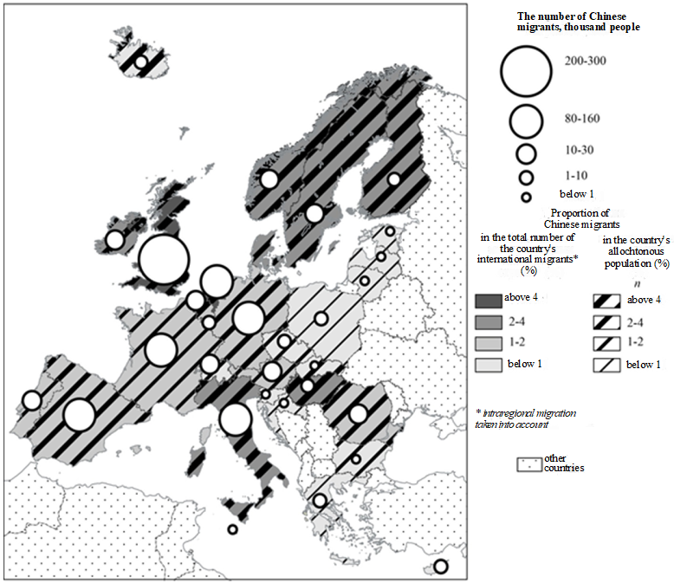

Fig. 2. Chinese migrants in the countries of the EU and the EFTA, 2011

Prepared based on [20, 23, 27].

1. *Huaqiao –* ‘Chinese migrants’ (Chinese 华) – are the Chinese holding the citizenship of the PRC or the special administrative regions of Hong Kong and Macau but permanently residing abroad. Historically, this term included temporary Chinese migrants rather than those living overseas on a permanent basis. This term is widely used in the Russian language literature.
2. *Waiji huaren –* ‘foreigners of Chinese descent’ (Chinese 外籍华人) – are the Chinese (*huaqiao* and their descendants), naturalised or holding a foreign citizenship by birth, and thus stripped off the citizenship of the PRC, the Republic of China, or the special administrative regions of Hong Kong and Macau. This term refers to the foreigners of Chinese descent. It is often abbreviated to *huaren –* the Chinese (Chinese 华人).
3. *Huayi* – ‘descendants of the Chinese’ (Chinese 华裔) – are people of the Chinese origin, descendants of Chinese migrants. This term refers to people born and raised outside China, who studied and socialised abroad, i.e. the migrants of the second, third generations. The *Huayi* are part of *huaren*.
4. The term *Haiwai* *huaren –* the overseas Chinese (Chinese 海外华人huaren) – refers to all the Chinese and people of Chinese origin living abroad, all the Chinese migrants, the overseas Chinse community, virtually the Chinese diaspora. All the official documents of the PRC and the Republic of China use this term to denote the Chinese living outside China, regardless of their citizenship. It refers to both the citizens of the PRC, the Republic pf China, and the special administrative regions of Hong Kong and Macau residing abroad and the naturalised ethnic Chinese. The diaspora includes the descendants of Chinese migrants and people born outside China in multi-ethnic families but preserving their ethnic identity and ties to the homeland.

The English language literature often uses a calque of the Chinese term to describe the diaspora (all the Chinese living outside China) – the overseas Chinese.

There can be no doubt about the existence of the Chinese diaspora as – according to the definition given by T. V. Poloskova – a robust cohesive social group (an association of people sharing a distinctive characteristic and participating in joint efforts guided by formal and informal institutions) that lives outside the country of the common geographical origin, has a common ethnic identity, and creates social, political, and economic institutions to support their identity and cohesion [15]. However, the varying terminology and principles of statistical recording cause the calculations of the size of the phenomenon to differ dramatically. The estimates of the number of the ethnic Chinese residing outside the country of origin range from 35 to 62 million people. In Beijing, they say with pride: ‘Everywhere where the Sun shines, there are our compatriots’ [12]. However, most of the Chinese community – above 70% – lives in the ASEAN countries. In comparison, the diaspora in Europe looks very modest, although its exact numbers are unknown. In 2011, the Europe – China Research and Advice Network (ECRAN) estimated the number of the ethnic Chinese in the EU countries at 2.3 million people, which is 1.5 times the estimate of the Overseas Chinese Affairs Commission (OCAC) [27, 31].

At the same time, when compared to the other regions of the world, Europe stands out in that its Chinese diaspora is highly mosaic (fig. 3). Firstly, the size of diasporas ranges widely from 650,000 in the UK to below 1,000 in some smaller countries. Secondly, the ratios between the *huaren* and *huaqiao* significantly differ, which translates into the predominant loyalty either to the local or to the Chinese authorities. Naturally, the former are prevalent in most of the EU member states with few exceptions (Italy, Spain, Finland, etc.). Thirdly, there are dramatic differences between European countries in the proportions of first-generation migrants with a ‘youth excess’, of highly educated people, and of qualified specialists striving to assimilate with Europeans and find prestigious employment in science, medicine, business, finance, education, management or arts. Such migrants determine the quantitative parameters of the diaspora. They are responsible for the ‘model minority’ stereotype, entrenched in the American society.[6] However, this stereotype is only partly accurate, since it applies only to the privileged part of the diaspora. There is another, ‘shadow’ part comprising manufacturing and service workers. Although they significantly differ in demographic parameters, they are brought together by a low level of education and well-being, as well as a poor command of the local language. Many of such migrants are undocumented. This is a separate and, as of yet, poorly studied, field. However, the emergence of what is called in classical political science ‘mutually reinforcing cleavages’ – deep divides between local citizens and deprived migrants speaking a different language and professing a different religion – is very unlikely in this case [28, 35, 37].

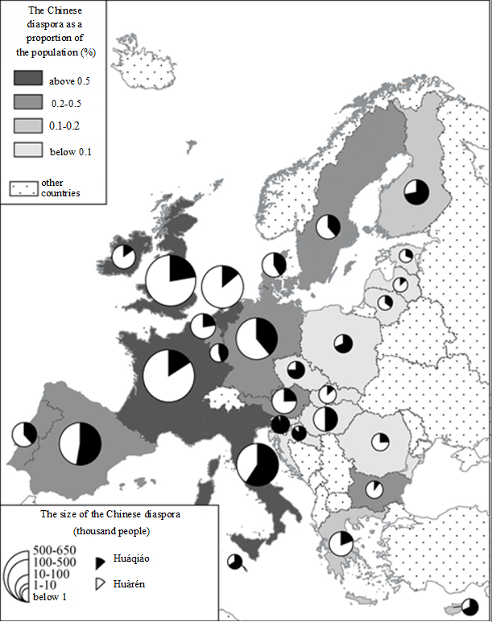

Fig. 3. The Chinese diaspora in the EU, 2011

Compiled by the author based on [20, 27, 31].

Today, there is parity between the first-generation Chinese migrants (53%) and the very diverse *huayi* in the EU. However, in the two thirds of the member states, the Chinese diaspora started to develop only recently, which testifies to the novelty of the phenomenon and stresses the need for relevant studies. A combined analysis of the size and age of the diaspora makes it possible to divide the EU member states into four major groups. Two groups are represented by countries with a significant proportion of the Chinese diaspora. New’ migrants account for less than 50% in the first group (the UK, France, Italy, the Netherlands, Ireland) and for over 50% in the second one (Germany and Spain). The two groups characterised by small Chinese diasporas are formed by analogy. Most of such countries have a large proportion of first-generation migrants (table 2). In a number of cases, for instance, in Sweden and the Baltics, they account for at least 85% of the respective diasporas.

Table 2

The EU member states grouped by the size and age of the Chinese diaspora, 2011

|  |  |  |  |
| --- | --- | --- | --- |
| Size category |  | Age category:* | |
| Size of the diaspora, thousand people | ‘Old’ | ‘Young’ |
| Large |  | *Large and ‘old’* | *Large and ‘young’* |
| Above 500 | UK, France, |  |
| 100–500 | Italy, Netherlands | Spain, Germany, |
| 50–100 | Ireland |  |
| Small |  | *Small and ‘old’* | *Small and ‘young’* |
| 10–50 | Belgium, Portugal | Austria, Sweden, Greece, Hungary Denmark |
|  | Below 10 | Bulgaria, Romania, Slovakia | Finland, the Czech Republic, Poland, Luxembourg, Cyprus, Slovenia, Lithuania, Croatia, Malta, Latvia, Estonia |

* The age of a diaspora is identified based on the proportion of first-generation migrants.

Compiled by the author based on [27].

**The gravitation of ‘new’ migration towards a few destination countries contributed to a greater differential in the Chinese diaspora distribution.** The size of diasporas has a distinct longitudinal gradient – it decreases eastward (fig. 2) – closely corresponding to the geography of the most economically developed and populous countries. In particular, this is proven by the high correlation coefficients for the EU member states (0.8174 for GDP and 0.7908 for the population size). Over 98% of the diaspora live in 10 countries, with the UK and France being new home to 50% of Chinese migrants. Large Chinese communities emerged in Germany, the Netherlands, Italy, and Spain. Note that the latter two states – which are often considered migrant exporters’ – offered an amnesty to illegal migrants. The Nordic countries and Eastern European states, the borders of which opened to Chinese migration only in the 1990s, pale against this background. The only exceptions are Hungary and Romania, which are characterised by an excessive proportion of the Chinese in the structure of international migrants. In other words, from the perspective of the core-periphery concept, the distribution of the Chinese diaspora in Europe is polycentric, with a distinctive regional core and a vast north-eastern periphery. Experts are expecting the diaspora to grow rapidly in the major countries of the core – the UK, France, Germany, and the Netherlands, as well as in Hungary, which still serves, to some degree, as a transit hub.

Due to a number of circumstances, the Chinese minority is almost absent in rural areas. The Chinese obviously gravitate towards cities. One might say that the distribution of the Chinese diaspora closely corresponds to Europe’s urban geography, with an emphasis on capital and port cities. The discrimination against the Chinese at the first stage of migration resulted in the emergence of ethnic enclaves – Chinatowns.[7] The elimination of the problem, as well as the new integration opportunities, which arose after World War II, explain why there are no large American-type Chinese enclaves in European agglomerations. The Chinese live dispersed across Europe. Sparsely populated, the few enclaves serve mostly as a scene for ethnic businesses. In the UK, the main centres of the Chinese diaspora settlement are London (30% of the diaspora), Birmingham, Glasgow, Manchester, and Liverpool. In France, these are Lyon and Marseille; in Italy, Milan, Florence, Turin, and Venice; in Spain, Madrid, Barcelona, Valencia, and Alicante; in Germany, Berlin, Hamburg, Bonn, Frankfurt, and Munich; in the Netherlands, Amsterdam; in Ireland, Dublin. The histories, sizes, and structures of the diaspora are very different across these cities. This information can provide the key to understanding the geographical origins of Chinese migrants. The diaspora of German agglomerations is dominated by people from Shanghai and the north-eastern province of China. Most of the Chinese residing in Dublin came from Guangdong and Hong Kong. The Amsterdam Chinese originate, primarily, from Hong Kong and the former Dutch colonies – Indonesia and Suriname.

**Ethnic ‘diffusion’ or part of the ‘European project’ in Beijing’s global strategy?** Not only the ‘new’ Chinese migration had a beneficial effect on the European sociodemographic structures and labour markets but also it contributed to the image of the ‘model minority’ and changed the structure and distribution of the ethnic diaspora in the region. Depending on the initial research objective, the Chinese diaspora can be studied from different perspectives. Firstly, one may employ the Euro- or Sinocentric approach. Secondly, such a research can be either specialised or comprehensive. In both cases, it is crucial to consider the most favourable conditions for migration and migration when economic and cultural globalisation has eliminated the need to make a final decision about permanent residence. Philip Q. Yang labelled this phenomenon the ‘transnationalism’ of Chinese migration [36].

Within the transition to the third global integration cycle, the problem of the Sinification of Europeans is assuming a partly local character amid the emerging struggle of major powers for world leadership. The current positions of the parties involved in the migration processes can be generalised and expressed by oriental proverbs. For China, the most suitable saying is ‘The best time to plant a tree was 20 years ago. The second best time is now’. For Europe, it is ‘Live in peace. When the spring comes it will take no effort for the flowers to bloom’. Remarkably, China considers migration part of its global strategy, which can be easily combined with other effective ‘soft power’[8] tools to engage European countries in cooperation in various fields – trade, projects and investment, research and development, education,[9] sociocultural initiatives, etc.

In Europe, the Chinse businesses are estimated at many times the size of the economic operations of all the other Asian minorities. Over the past six years, Chinese investment in the EU has increased tenfold [7]. According to EY Consulting, it grew threefold only in 2016 – from USD 30.1 billion to 85.8 billion. That year, the Chinese bought into 309 European companies. Here, Germany ranks first (68 companies), the UK second (47), and France and Italy third (34 each). For the sake of comparison, ten years ago, in 2007, the Chinese purchased 51 European companies [16]. Although the priorities of the Chinese are quite clear, investment from the country is very diverse in terms of geography. It is present in all the European states, including those of the Baltic region. In particular, the project 16+1[10] was launched as early as 2012 to promote cooperation with Central and Eastern European states. The central goal of the project is to ‘gain access to technology and research, international sales channels and major brands, to ensure the supply of raw materials for the needs of the Chinese economy. Another goal of Chinese businesses is investment in external infrastructure projects, as well as the granting of concessional loans to projects carried out by Chinese contactors’ [1].

In other words, China is here to stay. Moreover, official Beijing is closing repatriation projects, which were aimed to make up for human capital losses, and is embarking on a ‘serve the homeland from abroad’ strategy. The new strategy is designed to create a Sinocentric stratum that will serve as a factor of national influence in the countries with a high proportion of ethnic communities. Later, such interest groups are expected to entrench themselves in the socio-political and economic spheres of the country of destination and, when necessary, promote the interests of China. Thus, emphasis will be placed on the preservation and strengthening of the diaspora’s national identity as a factor of China’s future global political and economic superiority [3].

This study gives rise to a series of general and specific questions. The former relate to joint interdisciplinary efforts in studying the phenomenon of ethnic diasporas, the modernisation of the international migrant registration system, and the creation of a single centre for the registration of people living outside the country of birth. The specific questions focus on Russia, particularly, on the development of effective collaborations with the Russian diaspora, on the launch of international projects, and on a comprehensive consideration of international – primarily, Chinese – experience in implementing a ‘soft power’ policy.

***Acknowledgement***

*This study was supported by a grant from the Russian Foundation for Basic Research (project 16-06-00492 ‘The City-Centric Model for the Spatial Organisation of the World Economy’).*

References

1. Belyakov, D. 2017, Beijing's Strategy in Central Europe, *SONAR 2050*, 01.12.2017, available at: http://www.sonar2050.org/publications/kitayskiy-proekt-161-mify-i-realnost/ (ac­cessed 27.05.2018) (in Russ.).

2. Vishnevsky, A. G., Dmitriev, R. V. 2016, Global Demographic Processes in the XX — Early XXI centuries, *Geografiya mirovogo razvitiya* [Geography of World Development], no. 3, p. 197—229 (in Russ.).

3. Galstyan, A. 2018, Chinese Diasporas Began to Seize Economies of the World, *Insti­tute of Social and Economic Development*, available at: https://is.gd/R1eDoz (accessed 21.06.2018) (in Russ.).

4. Gladkiy, Yu. N., Gladkiy, I. Yu., Eidemiller, K. Yu. 2017, Islamic Diffusion in the Baltics: The Fruit of European Multiculturalism, *Balt. Reg.,* Vol. 9, no. 3, p. 30—44. doi: 10.5922/2079-8555-2017-3-3**.**

5. Diasporas in the Modern World: The Regional Context and the Potential for Sustaina­ble Development of the Country of Origin, 2018, Materials of the International Scientific Conference, *International Organization for Migration*, mission to Moldova, Chisinau, De­cember 21, 2017, 594 p. (accessed 21.06.2018) (in Russ.).

6. The PRC Law on the Protection of Investors and the Rights of Returned Huatsiao and QiaoJuang Relatives, item 2, available at: http://www.chinaqw.com.cn/node2/node2796/node 2883/node3179/userobject6ai3723.html (accessed 12.04.2018) (in Chines).

7. How Much Does China Invest in Europe, 2017, *Sputnik*, 03.11.2017, available at: http//sputnik.by/infographics/20171103/1031743903/kitajskie-investicii-v-strany-es.html (ac­cessed 27.05.2018 (in Russ.).

8. Kasatkin, P. I., Ivkina, N. V. 2018, Cultural and Educational Components of the «Soft Power» of the EU, *Comparative Politics Russia,*Vol. 9, no. 1, p. 26—36 (in Russ.).

9. Kondratieva, T.2010, Diasporas in the Modern World: The Evolution of the Phenome­non and Concepts, *«Perspektivy». Fond istoricheskoi perspektivy* ["Prospects". Historical Perspective Fund], 27 February 2010,available at: http://www.perspektivy.info/print.php?ID =48886 (accessed 27.05.2018) (in Russ).

10. Korobkov, A. V. 2016, The Largest Migration Systems in the World: General Trends and Differences. In: Kolosov, V. A., Sluka, N. A. *Geografiya mirovogo khozyaistva: traditsii, sovremennost', perspektivy* [Geography of the World Economy: Traditions, Modernity, Pro­spects] Moscow-Smolensk, p. 313—327 (in Russ).

11. Kuznetsova, T. Yu. 2012, *Demografiya s osnovami etnografii* [Demography with the Basics of Ethnography], Kaliningrad, 93 p. (in Russ).

12. Larin, A. G. 2008, *Kitai i zarubezhnye kitaitsy* [China and overseas Chinese], Mos­cow, 96 p. (in Russ.).

13. Bulatov, A. S. (ed.) 2017, *Mirovaya ekonomika i mezhdunarodnye Otnosheniya* [World Economy and International Relations], 916 p. (in Russ.).

14. Macron Said that the Migration Crisis in the EU has Grown into a Political, 2018, *Tass,* Russian News Agency, June 24, 2018, available at: http://tass.ru/mezhdunarodnaya- panorama/5319360 (accessed 26.06.2018) (in Russ.).

15. Poloskova, Т. V. 2002, *Sovremennye diaspory: vnutripoliticheskie i mezhdunarodnye aspekty* [Modern Diasporas: Domestic Political and International Aspects], Moscow, 284 p. (in Russ.).

16. Rozhdestvenskaya, Ya. 2017, Chinese Investments in Europe Reached a Record Level,*Kommersant*, January 26, 2017, available at: https://www.kommersant.ru/doc/3201876(ac­cessed 27.05.2018) (in Russ.).

17. Felde, A. V. 2015, «New» Chinese Migration as a Factor in China's Modernization. Master. Thes., Ekaterinburg, Ural Federal University named after the first President of Russia BN. Yeltsin, 122 p., available at: http://elar.urfu.ru/bitstream/10995/31582/1/m_th_a. v.felde_ 2015.pdf (accessed 20.05.2018) (in Russ.).

18. Shatilo, D. P. 2018, Social Differentiation of Urban Areas (Based on the Cost of Housing and Resettlement of Immigrants in Major European Capitals), PhD Thes., Moscow, Lomonosov Moscow State University named after, 27 p. (in Russ.).

19. *Chinatownology*, available at: http://www.chinatownology.com (accessed 12.04.2018).

20. *Eurostat*, available at: http://ec.europa.eu/eurostat (accessed 12.04.2018).

21. Global Migration: Demographic Aspects and Its Relevance for Development, 2013, *U. N. Department of Economic and Social Affairs, Technical Paper*, no. 6.

22. *Global Migration Map*: Origins and Destinations, 1990—2017, available at: http:// www.pewglobal.org/2018/02/28/global-migrant-stocks/?country=CN&date=2017 (accessed 12.04.2018).

23. Human Development *Report*, 2015, available at: http://hdr.undp.org/sites/default/ files/hdr_2015_statistical_annex.pdf (дата обращения 15.04.2018).

24. Inkpen Ch. 7 Facts About World Migration, 2014, Pew *Research Center*, available at: http://www.pewresearch.org/fact-tank/2014/09/02/7-facts-about-world-migration/ (accessed 15.04.2018).

25. *International Migration Report* 2015, 2016, N. Y., U. N., Department of Economic and Social Affairs, Population Division.

26. Joppke, Ch. 2011, Trends in European Immigration Policies, In: Burgess, J. P., Gut­wirth, S. (eds.) *A Threat Against Europe? Migration and Integration*, Brussels.

27. Latham, K., Wu, B. 2013, *Chinese Immigration into the EU: New Trends, Dynamics and Implications*, London.

28. Lipset, S. M. 1960, *Political Man*. *Garden City,* N. Y.

29. *Ministry of Commerce People’s Republic of China*, available at: http://english. mofcom.gov.cn/article/statistic/foreigninvestment (accessed 12.04.2018).

30. *Open Doors, Project-Atlas of Student Mobility*, 2012, Institute of International Edu­cation, N. Y.

31. Overseas Community Affairs Council (OCAC), 2018, *United Nations Statistics Divi­sion*, available at: http://www.ocac.gov.tw (accessed 15.04.2018).

32. Parker, D. 1998, *Chinese People in Britain: Histories, Futures and Identities*, L.

33. Pieke, F. 2002, *Recent Trends in Chinese Migration to Europe:**Fujianese Migration in Perspective*, Geneva, 60 р.

34. Ravenstein, E. G. 1889, The Laws of Migration, *Journal of the Royal Statistical Soci­ety*, Vol. 52, p. 241—301.

35. Rokkan, S. 1967, *Geography, Religion and Social Class: Cross-cutting Cleavages in Norwegian Politics*, N. Y.

36. Tan, C.-B. (ed.) 2013, *Routledge Handbook of the Chinese Diaspora*, N. Y., 512 p.

37. Simmel, G. 1908, *Soziologie*, Leipzig.

The authors

Prof. Nikolai A. Sluka, Department of Geography of World Economy, Lomono­sov Moscow State University, Russia.

E-mail: sluka2011@yandex.ru

ORCID https://orcid.org/0000-0002-2974-1027

Dr Andrei V. Korobkov, Professor, Middle Tennessee State University, USA.

E-mail: andrei.korobkov@mtsu.edu

Pavel N. Ivanov,Master Student, Department of Geography of World Economy, Lo­monosov Moscow State University, Russia.

E-mail: pavel.ivanov.n@yandex.ru

**To cite this article:**

Sluka, N. A., Korobkov, A. V., Ivanov, N. P. 2018, The Chinese Diaspora in the EU Countries, Balt. Reg., Vol. 10, no. 3, p. 80—95. doi: 10.5922/2079-8555-2018-3-5.

1. This estimate does not take into account undocumented or irregular migrants.
2. The UK was the preferred destination for the ethnic Chinese from Malaysia and Hong Kong, the Netherlands for those from Indonesia and Surinam, and France for those from Indochina.
3. The European countries, all the countries of the EU, consider the Republic of China part of the PRC and do not establish diplomatic ties with the former.
4. For example, from October 1988 to April 1992, 45,000 transit of migrants from China crossed Hungary. Later, they scatter across Europe and, partly, North America [33, р. 16].
5. After the incorporation of Hong Kong and Macau, on October 31, 2000, amendments were made to the respective laws.
6. The term ‘model minority’ was coined by the sociologist William Peterson in his essay ‘Success Story: Japanese American Style’ published in the *New York Times* in 1966. It referred to Asian Americans as ethnic minorities that managed to achieve success in the US, despite marginalisation.
7. The largest Chinatowns are found in Paris, London, and Liverpool [19].
8. The term ‘soft power’ is interpreted very differently. In China, it means ‘wise power’. Principally, it stands for the Confucian wisdom and the cultural identity, which serve as major guidelines for the country’s foreign policy decision-making [8].
9. For example, according to the Ministry of Education of China, as of the end of 2017, European countries accounted for mover 1/3rd of all the Confucius Institutes and Classrooms.
10. It brings together eleven EU member states and five Balkan countries (Albania, Bulgaria, Bosnia and Herzegovina, Hungary, Latvia, Lithuania, Macedonia, Poland, Romania, Serbia, Slovakia, Slovenia, Croatia, Montenegro, the Czech Republic, and Estonia).