THERMODYNAMIC DATA and ASSESMENT of the Cu-Pb-Zn SYSTEM

V.A. Lysenko, V.P. Vassiliev, A.N. Mitrofanova, N.B. Zorov, L.G. Sevastyanova, L.E. Gorlenko, A.M. Parfenova, E.A. Tveritinova.

Chemistry Department, Lomonosov Moscow State University, 119992 Moscow, Russia
e-mail: valeryvassiliev@yahoo.fr

A strategic goal of our research is the studying of thermodynamic properties and liquid separation in the five-component system Cu-In-Pb-Sn-Zn and their subsystems by means of EMF method and thermodynamic modeling [1-4]. The general strategy of this work, aimed on creation of industrial thermodynamic data bank has been developed earlier [5].
In this work we measured four alloys in the ternary Cu-Pb-Zn system (Fig.1) and calculated the phase equilibria in it. Results of the EMF measurements of the Cu-Pb-Zn system for isopleth Cu_{x}(Pb_{0.5}Zn_{0.5})_{1-x} Compositions of alloys: x_{Cu}= 0.0155, 2) x_{Cu}= 0.0204, 3) x_{Cu}= 0.02547, 4) x_{Cu}= 0.03048; E(T) mV for the domain L₁+L₂ :

- E= 4.634-1.3585⋅10⁻²⋅T+1.07252⋅10⁻⁵⋅T²; n=37; $S_{o}^{2}$= 0.153⋅10⁻⁴ mV²; 2$S_{o}$=±0.008mV
2) E= 4.929-1.4991⋅10⁻²⋅T+1.27899⋅10⁻⁵⋅T²; n=39; $S_{o}^{2}$= 1.1⋅10⁻⁴ mV²; 2$S_{o}$=±0.02mV
3) E= 8.417-2.4754⋅10⁻²⋅T+2.001⋅10⁻⁵⋅T²; n=19; $S_{o}^{2}$= 0.3⋅10⁻⁴ mV²; 2$S_{o}$=±0.01mV
4) E= 4.102-1.2993⋅10⁻²⋅T+1.21824⋅10⁻⁵⋅T²; n=17; $S_{o}^{2}$= 0.3⋅10⁻⁴ mV²; 2$S_{o}$=±0.01mV
E(T) mV for the domain L₁+L₂ +ε:
- E= 7.161+1.1182⋅10⁻²⋅T; n= 30;$S_{o}^{2}$= 0.3⋅10⁻⁴ mV²; 2$S_{o}$=±0.01mV

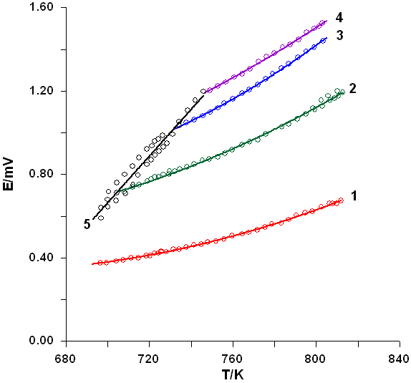
Fig.1. Cu_{x}(Pb_{0.5}Zn_{0.5})_{1-x} system. L₁+L₂ :1) x_{Cu}= 0.0155, 2) x_{Cu}= 0.0204, 3) x_{Cu}= 0.02547, 4) x_{Cu}= 0.03048; 5) heterogeneous region L₁+L₂+ε

[1] Vassiliev V.P., Lysenko V.A. Thermodynamic Assessment of the Cu-In-Pb System, J. Alloys Compds 629 (2015) 326-331
[2] Vassiliev V.P., Lysenko V.A., Weiping Gong. New EMF Measurements and Thermodynamic Evaluation of the In-Pb-Zn System. J. Alloys. Compds 564 (2013) 49-54
[3] Vassiliev V.P., Lysenko V.A., Sevastyanova L.G, Buslov I.V., Panyushkin V.V.
New thermodynamic data of the quaternary In-Pb-Sn-Zn system. XIX International Conference on Chemical Thermodynamics in Russia. Moscow, 24-28 June, 2013.
[4] David N., Vassiliev V., Hertz J., Fiorani J.M.,Vilasi M. Measurements EMF and Thermodynamic Description of the Pb-Sn-Zn Liquid Phase. Z.Metalknd, 95 (2004) 1-8
[5] Naguet Ch , Bourkba A., Fiorani J.M., Vassiliev V., Sauvanaurd J., Hertz J. A strategy to establish an industrial thermodynamic data bank. The ternary (Pb, Sn, Zn) liquid phase in the zinc purification process. Extension to quaternary system (M, Pb, Sn, Zn). Thermochimica Acta 314 (1998) 55-68

