**Mathematical Setting Eqations of Linear Contact**

**of the Spiral Rope – Phylum VARRINGTON**

Eugene Kalentev1,a**,** Valerii Tarasov1,b

and Aleksandr Korshunov 1,c

1 Institute mechanics Ural Branch of the Russian Academy of Sciences,

street T. Baramzina, 34, 426067 Izhevsk, Russian Federation

a EugeneDavis@mail.ru, b tvv@udman.ru, c kai@istu.ru

**Keywords:** set of equations, linear contact, a spiral rope.

**Abstract:** The article deals with the problem of obtaining new solutions of a system of linear contact equations for a spiral rope of the "Varrington" type, which did not require the use of the approximation method. The high complexity of the method under consideration substantially limits its use and requires the use of special software [1, 2]. The question of convergence of the iterative process in the course of computations also usually arises. The main idea is based on the representation of the initial dependencies in the form of series and the subsequent solution of the equations obtained. The proposed procedure can be easily adapted to calculate the geometry of spiral ropes and locks of various types: "Forces", "Varrington-forces" and several others [3,4].

Introduction

It so happened that steel ropes are traditionally widely used to provide the functioning of a number of samples of modern technology, especially for lifting and transporting machines and mechanisms. Currently, there is a fairly large number of rope sizes, but as the key design factors determining the structure and applicability of a particular type of rope are such as: the cross-sectional profile of an individual wire, the circuit of the contact between the wires in the chain, the order of laying, the contact of the wire in strands.

In the usual case, for rope constructions, cables with spiral axes are single- or multi-stage, laid around the central wire of a straight line [5,6]. Ropes of regular laying are also known as twisted ropes. If we continue laying the twisted rope, a so-called double-rope rope will be obtained, where the twisted rope will be called a yarn. It should be noted that for double-laid cables, the central wire is in the form of a spiral line, so you can get a rope of any order. The most common scheme is twisted and double ropes [7].

Theoretical part

If the wires are stacked in strands in layers with different steps, the layers touch at the points. In the event that the steps of the wire layer are equal, the wires of the upper layer are placed in the grooves formed by the wires of the lower layer, then the threads have a linear contact. For a large number of layers, a combination of point and line contacts between the layers of wire is possible [8]. Consider a new solution to the system of linear contact equations for the spiral rope of the Warrington type. In this case, the use of the approximation method was not required.

On the basis of an approximation method in work [1] the decision of set of equations of linear contact (1) wires a spiral rope of phylum "Varrington" (fig. 1) has been received [9]. High labour input of this method confines its applications and almost always demands any program realisation. Besides there is opened a question concerning convergence of iterative process. Considering above told, we will receive new decisions of system (1).

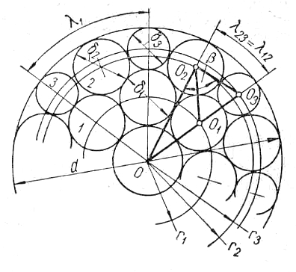

Fig. 1. The Cross-section of a spiral rope of phylum "Varrington"

In drawing it is designated - radiuses of beds wires «1», «2», «3» accordingly, - diameters wires beds «1», «2», «3» accordingly, - polar angles of contact wires «1», «1-2», «1-3» accordingly.

 (1)

Where



Expressions for distance squares, between screw axes linearly contacting wires:

 (2)

From drawing 1 it is possible to define:

 (3)

For reception of new decisions we will arrive as follows.

The initial data for calculation: - diameter of a spiral rope, - a step-lay, - a design (quantity wires on beds). For simplification of calculations we will take over known size - diameter wires «2». Thus, it is necessary to define five unknown persons radiuses of beds wires «1», «2», «3» and diameters wires «1» and «3». We will write down interrelations for angles of lay wires:

 (4)

Expressions for the auxiliary equations taking into account (4) will become:

 (5)

From the first equation of system (1) we will find expression for:

 (6)

Considering (6) we will write down new expressions for using (4) and (5):

 (7)

Auxiliary expression for taking into account (4) and (5) will become:

 (8)

Further we will express values of diameters from the first and second expressions of system (1) and we will substitute them in the sixth expression of the specified system, taking into account (2) we will receive:

 (9)

Let's write down expression (9) in the form of function from:

(10)

Let's spread out the yielded function abreast Maklorena with degree of a residual member equal 3:

 (11)

Let's reject a residual member and we will resolve expression (11) rather:

 (12)

Where



Discussion

From the second expression of system (1) it is easily received:

 (13)

Substituting the second and fourth equations of system (1) in the third, we cluster all members in the left part and it is received:

 (14)

Let's write down expression (14) in the form of function from:

 (15)

Let's spread out the received expression abreast Maklorena with degree of a residual member equal 3:

 (16)

For an illustration of accuracy of used approximating we will result function graphs (fig. 2).

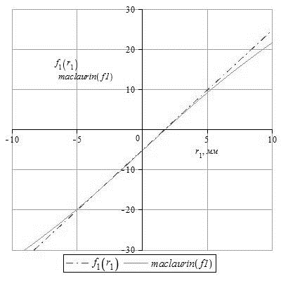

Fig. 2. Function graphs 

Having rejected a residual member and having resolved expression (16) rather:

 (17)

Where



Conclusions

Substituting (17) in (4), (5) we will write down new expressions for, then using the fourth expression of system (1), we find diameter wires an inside layer:

 (18)

At last stage it is found the approached value of diameter of the central strand:

 (19)

It is necessary to notice that reception of more exact expression is interfaced to definition of the form of section of a strand in a cross-section of a rope and its orientation.

As a result new decisions of system (1) are received. The yielded procedure can be easily adapted for calculation of geometry of spiral ropes and locks of various phylums: "Forces", "Varrington-forces", etc.

References

1. Glushko M. F. Steel elevating ropes. - Kiev, Technics, 1966. – 327p.
2. J. Wu, The finite element modeling of spiral ropes. International Journal of Coal Science and Technology, Volume 1, Issue 3, 1 September 2014, pp. 346-355
3. F. Luz, L. Silva, S. Amico and C. Cimini, Tensile behavior of a CFRP wire rope with independent core: Analytical and numerical analyses. 16th European Conference on Composite Materials, ECCM 2014, Seville; Spain; 22 June 2014 through 26 June 2014;
4. P. Božek, E. Pivarčiová, Flexible manufacturing system with automatic control of product quality. In Strojarstvo. Vol. 55, No. 3 (2013), online, pp. 211-221
5. G. Fedorko, V. Molnár, Ž. Ferková, P. Peterka, J. Krešák and M. Tomašková, Possibilities of failure analysis for steel cord conveyor belts using knowledge obtained from non-destructive testing of steel ropes. Engineering Failure Analysis, Volume 67, 1 September 2016, pp. 33-45
6. P, Božek, P. Molda and M. Tóthová, Modelovanie rozbehu kabíny lanovej dráhy. Mathematical analyses of motoring cable synchronization. In *Process Control 2004 : 6th International Scientific-Technical Conference `Process Control 2004`, Kouty nad Desnou, Czech Republic, 8.-11.6.2004*. Pardubice : Univerzita Pardubice, 2004, pp. R273/1-6.
7. A. Roduner, A. Vogel and V. Budimir, Spiral rope nets for rockfall protection - Tests, design, application. Regional Symposium of the International Society for Rock Mechanics: Rock Engineering in Difficult Ground Conditions - Soft Rocks and Karst, EUROCK 2009; Dubrovnik, Cavtat; Croatia; 29 October 2009 through 31 October 2009; Code 89361 2010, pp. 735-740
8. Futáš, P., Pribulová, A., Fedorko, G., Molnár, V. Influence of steel scrap in the charge on the properties of gray cast iron. ISIJ International, Volume 57, Issue 2, 2017, pp. 374-379
9. D. Flum, A. Roduner, Findings from large-scale field tests of spiral rope nets for rock protection. 2010, European Rock Mechanics Symposium, EUROCK 2010; Lausanne; Switzerland; 15 June 2010 through 18 June 2010; Code 89434, Pages 625-628